**Boolean Algebra**

**Exercise 1** - Write a boolean equation in sum-of-products canonical form for each of the truth tables, then **minimise** to **minimum terms** using **Boolean algebra theorems**. Finally draw the combinatorial circuit and simulate it on Deeds to check the correctness

|  |  |  |
| --- | --- | --- |
| **A** | **B** | **OUT** |
| 0 | 0 | **1** |
| 0 | 1 | **0** |
| 1 | 0 | **0** |
| 1 | 1 | **0** |

|  |  |  |  |
| --- | --- | --- | --- |
| **A** | **B** | **C** | **Y** |
| 0 | 0 | 0 | **0** |
| 0 | 0 | 1 | **0** |
| 0 | 1 | 0 | **1** |
| 0 | 1 | 1 | **1** |
| 1 | 0 | 0 | **0** |
| 1 | 0 | 1 | **1** |
| 1 | 1 | 0 | **1** |
| 1 | 1 | 1 | **0** |

|  |  |  |  |
| --- | --- | --- | --- |
| **A** | **B** | **C** | **Y** |
| 0 | 0 | 0 | **0** |
| 0 | 0 | 1 | **0** |
| 0 | 1 | 0 | **0** |
| 0 | 1 | 1 | **0** |
| 1 | 0 | 0 | **0** |
| 1 | 0 | 1 | **1** |
| 1 | 1 | 0 | **1** |
| 1 | 1 | 1 | **1** |

a)

b) c)

|  |  |  |  |  |
| --- | --- | --- | --- | --- |
| **A** | **B** | **C** | **D** | **Y** |
| 0 | 0 | 0 | 0 | **0** |
| 0 | 0 | 0 | 1 | **1** |
| 0 | 0 | 1 | 0 | **0** |
| 0 | 0 | 1 | 1 | **0** |
| 0 | 1 | 0 | 0 | **0** |
| 0 | 1 | 0 | 1 | **1** |
| 0 | 1 | 1 | 0 | **0** |
| 0 | 1 | 1 | 1 | **0** |
| 1 | 0 | 0 | 0 | **0** |
| 1 | 0 | 0 | 1 | **0** |
| 1 | 0 | 1 | 0 | **0** |
| 1 | 0 | 1 | 1 | **0** |
| 1 | 1 | 0 | 0 | **0** |
| 1 | 1 | 0 | 1 | **0** |
| 1 | 1 | 1 | 0 | **1** |
| 1 | 1 | 1 | 1 | **1** |

|  |  |  |  |  |
| --- | --- | --- | --- | --- |
| **A** | **B** | **C** | **D** | **Y** |
| 0 | 0 | 0 | 0 | **0** |
| 0 | 0 | 0 | 1 | **0** |
| 0 | 0 | 1 | 0 | **0** |
| 0 | 0 | 1 | 1 | **1** |
| 0 | 1 | 0 | 0 | **0** |
| 0 | 1 | 0 | 1 | **0** |
| 0 | 1 | 1 | 0 | **0** |
| 0 | 1 | 1 | 1 | **1** |
| 1 | 0 | 0 | 0 | **1** |
| 1 | 0 | 0 | 1 | **1** |
| 1 | 0 | 1 | 0 | **1** |
| 1 | 0 | 1 | 1 | **0** |
| 1 | 1 | 0 | 0 | **0** |
| 1 | 1 | 0 | 1 | **0** |
| 1 | 1 | 1 | 0 | **0** |
| 1 | 1 | 1 | 1 | **0** |

d)

e)

a)!A!B b) A!BC+B!C+B!A c)AB+AC d)!A!CD+ABC e)!ACD+A!B!C+A!B!D

**Exercise 2** - Fill the truth table and the time diagram; then write the boolean equation in sum-of-product or product-of-sum canonical form and **minimise** to **minimum terms** using **Boolean algebra theorems**; finally design the circuit using DEEDS to check the correctness of your answers

|  |  |  |  |
| --- | --- | --- | --- |
| **A** | **B** | **C** | **OUT** |
|  |  |  |  |
|  |  |  |  |
|  |  |  |  |
|  |  |  |  |
|  |  |  |  |
|  |  |  |  |
|  |  |  |  |
|  |  |  |  |

**Exercise 3** - Fill the truth table and the time diagram; then write the boolean equation in sum-of-product or product-of-sum canonical form and **minimise** to **minimum terms** using **Boolean algebra theorems**; finally design the circuit using DEEDS to check the correctness of your answers

|  |  |  |
| --- | --- | --- |
| **A** | **B** | **F** |
|  |  |  |
|  |  |  |
|  |  |  |
|  |  |  |

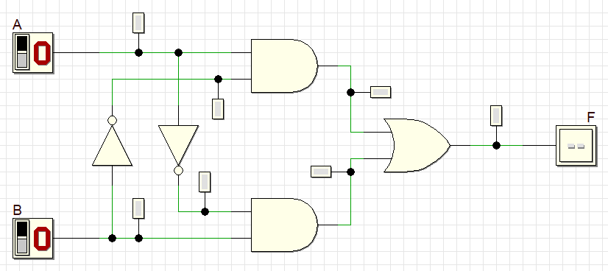

|  |  |  |  |
| --- | --- | --- | --- |
| **A** | **B** | **C** | **OUT** |
|  |  |  |  |
|  |  |  |  |
|  |  |  |  |
|  |  |  |  |
|  |  |  |  |
|  |  |  |  |
|  |  |  |  |
|  |  |  |  |

**Exercise 4** - Fill the truth table and the time diagram; then write the boolean equation in sum-of-product or product-of-sum canonical form and **minimise** to **minimum terms** using **Boolean algebra theorems**; finally design the circuit using DEEDS to check the correctness of your answers

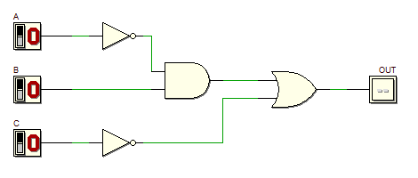

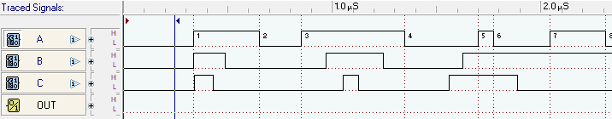

|  |  |  |  |
| --- | --- | --- | --- |
| **A** | **B** | **C** | **OUT** |
|  |  |  |  |
|  |  |  |  |
|  |  |  |  |
|  |  |  |  |
|  |  |  |  |
|  |  |  |  |
|  |  |  |  |
|  |  |  |  |

**Exercise 5** - Fill the truth table and the time diagram; then write the boolean equation in sum-of-product or product-of-sum canonical form and **minimise** to **minimum terms** using **Boolean algebra theorems**; finally design the circuit using DEEDS to check the correctness of your answers

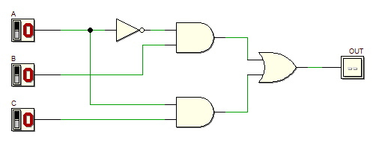



|  |  |  |  |
| --- | --- | --- | --- |
| **A** | **B** | **C** | **OUT** |
|  |  |  |  |
|  |  |  |  |
|  |  |  |  |
|  |  |  |  |
|  |  |  |  |
|  |  |  |  |
|  |  |  |  |
|  |  |  |  |

**Exercise 6** - Fill the truth table and the time diagram; then write the boolean equation in sum-of-product or product-of-sum canonical form and **minimise** to **minimum terms** using **Boolean algebra theorems**; finally design the circuit using DEEDS to check the correctness of your answers

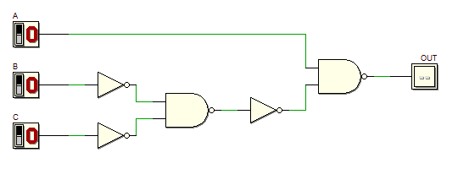



|  |  |  |  |
| --- | --- | --- | --- |
| **A** | **B** | **C** | **OUT** |
|  |  |  |  |
|  |  |  |  |
|  |  |  |  |
|  |  |  |  |
|  |  |  |  |
|  |  |  |  |
|  |  |  |  |
|  |  |  |  |

**Exercise 7** - Fill the truth table and the time diagram; then write the boolean equation in sum-of-product or product-of-sum canonical form and **minimise** to **minimum terms** using **Boolean algebra theorems**; finally design the circuit using DEEDS to check the correctness of your answers

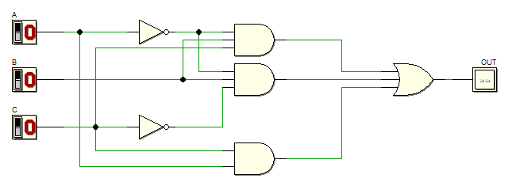



|  |  |  |  |
| --- | --- | --- | --- |
| **A** | **B** | **C** | **OUT** |
|  |  |  |  |
|  |  |  |  |
|  |  |  |  |
|  |  |  |  |
|  |  |  |  |
|  |  |  |  |
|  |  |  |  |
|  |  |  |  |

**Exercise 8** - Fill the truth table and the time diagram; then write the boolean equation in sum-of-product or product-of-sum canonical form and **minimise** to **minimum terms** using **Boolean algebra theorems**; finally design the circuit using DEEDS to check the correctness of your answers

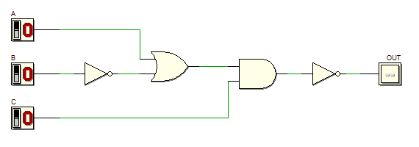



|  |  |  |  |
| --- | --- | --- | --- |
| **A** | **B** | **C** | **OUT** |
|  |  |  |  |
|  |  |  |  |
|  |  |  |  |
|  |  |  |  |
|  |  |  |  |
|  |  |  |  |
|  |  |  |  |
|  |  |  |  |

**Exercise 9** - Fill the truth table and the time diagram; then write the boolean equation in sum-of-product or product-of-sum canonical form and **minimise** to **minimum terms** using **Boolean algebra theorems**; finally design the circuit using DEEDS to check the correctness of your answers

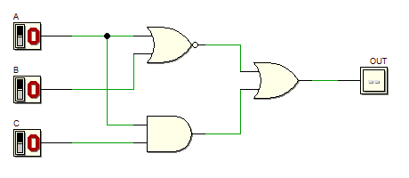



|  |  |  |  |
| --- | --- | --- | --- |
| **A** | **B** | **C** | **OUT** |
|  |  |  |  |
|  |  |  |  |
|  |  |  |  |
|  |  |  |  |
|  |  |  |  |
|  |  |  |  |
|  |  |  |  |
|  |  |  |  |

**Exercise 10** - Fill the truth table and the time diagram; then write the boolean equation in sum-of-product or product-of-sum canonical form and **minimise** to **minimum terms** using **Boolean algebra theorems**; finally design the circuit using DEEDS to check the correctness of your answers

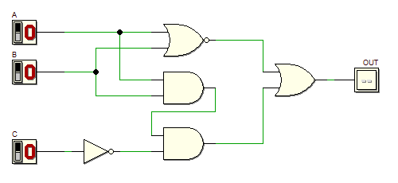



**Exercise 11** - Fill the truth table; then write the boolean equation **in sum-of-product or product-of-sum** canonical form and **minimise** to **minimum terms** using **Boolean algebra theorems**; finally design the circuit using DEEDS to check the correctness of your answers.   
**This is a 2-BIT COMPARATOR, it checks whether the value A2A1 is equal to B2B1**

|  |  |  |  |  |
| --- | --- | --- | --- | --- |
| **A1** | **B1** | **A2** | **B2** | **OUT** |
|  |  |  |  |  |
|  |  |  |  |  |
|  |  |  |  |  |
|  |  |  |  |  |
|  |  |  |  |  |
|  |  |  |  |  |
|  |  |  |  |  |
|  |  |  |  |  |
|  |  |  |  |  |
|  |  |  |  |  |
|  |  |  |  |  |
|  |  |  |  |  |
|  |  |  |  |  |
|  |  |  |  |  |
|  |  |  |  |  |
|  |  |  |  |  |

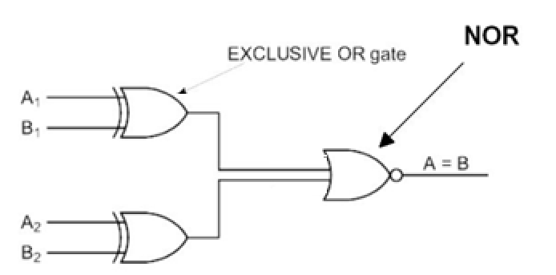

**Exercise 12** - Fill the truth table and the time diagram; then write the boolean equation **in sum-of-product or product-of-sum** canonical form and **minimise** to **minimum terms** using **Boolean algebra theorems**; finally design the circuit using DEEDS to check the correctness of your answers.   
**This is a 1-BIT SUMMATOR, it sums bit A, bit B and the input carry; it generates the sum and the carry output**

|  |  |  |  |  |
| --- | --- | --- | --- | --- |
| **A** | **B** | **CarryIn** | **Sum** | **CarryOut** |
|  |  |  |  |  |
|  |  |  |  |  |
|  |  |  |  |  |
|  |  |  |  |  |
|  |  |  |  |  |
|  |  |  |  |  |
|  |  |  |  |  |
|  |  |  |  |  |

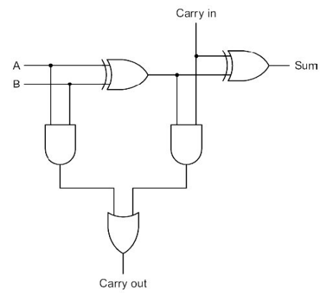

|  |  |  |  |
| --- | --- | --- | --- |
| **A** | **B** | **C** | **OUT** |
|  |  |  |  |
|  |  |  |  |
|  |  |  |  |
|  |  |  |  |
|  |  |  |  |
|  |  |  |  |
|  |  |  |  |
|  |  |  |  |

**Exercise 13** - Fill the truth table and the time diagram; then write the boolean equation in **sum-of-product or product-of-sum** canonical form and **minimise** to **minimum terms** using **Boolean algebra theorems**; finally design the circuit using DEEDS to check the correctness of your answers.

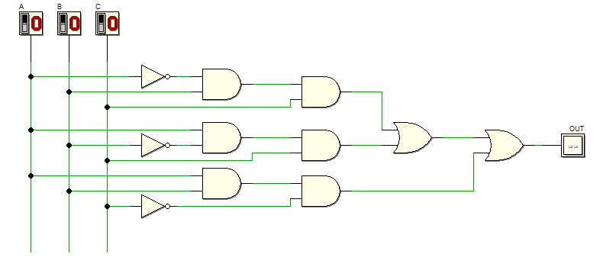



**Exercise 14** - Fill the truth table and the time diagram; then write the boolean equation in sum-of-product or product-of-sum canonical form and **minimise** to **minimum terms** using **Boolean algebra theorems**; finally design the circuit using DEEDS to check the correctness of your answers.

|  |  |  |  |
| --- | --- | --- | --- |
| **A** | **B** | **C** | **OUT** |
|  |  |  |  |
|  |  |  |  |
|  |  |  |  |
|  |  |  |  |
|  |  |  |  |
|  |  |  |  |
|  |  |  |  |
|  |  |  |  |

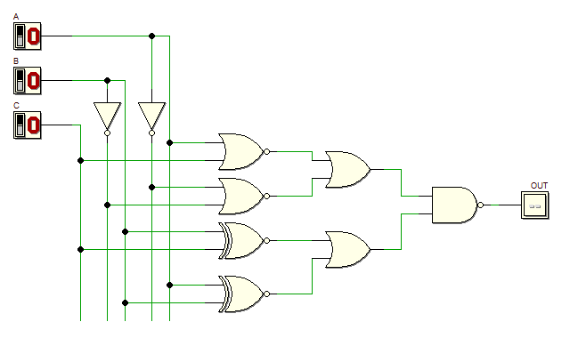



**Exercise 15** - Fill the truth table and the time diagram; then write the boolean equation in sum-of-product or product-of-sum canonical form and **minimise** to **minimum terms** using **Boolean algebra theorems**; finally design the circuit using DEEDS to check the correctness of your answers.

|  |  |  |  |
| --- | --- | --- | --- |
| **A** | **B** | **C** | **OUT** |
|  |  |  |  |
|  |  |  |  |
|  |  |  |  |
|  |  |  |  |
|  |  |  |  |
|  |  |  |  |
|  |  |  |  |
|  |  |  |  |

